Importing Wolfspeed symbols and models:
1) Go to ‘https://www.wolfspeed.com/tools-and-support/power/ltspice-and-plecs-models/’.
2) Download the ‘All SPICE Models.zip’ file.
3) Unzip the downloaded file and navigate to the ‘Discretes’ folder for our MOSFET models or ‘Schottkys’ for our diode models.
4) Create a folder to store the WS model files. For example, ‘C:\Users\ExampleUser\WS_LTspice_Library\’.
5) Copy the .asy and .lib files into your desired directory (for MOSFETS, copy nmos_TO247_3L.asy and nmos_TO247_4L for 3 lead, and 4 lead devices (all 7 lead devices are also modeled as 4 lead devices) and for diodes every model has its own separate symbol).
6a) For LTspice version 24=> Open LTspice and go to Tools-> Settings-> Search Paths. Enter the desired path into both the symbol and library search paths (see figure below).
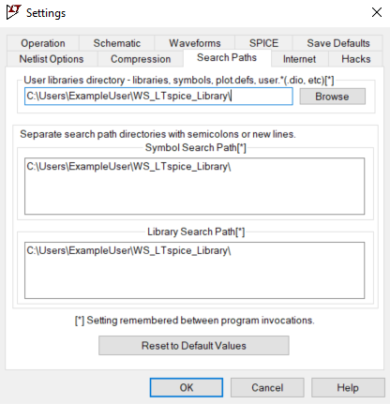
6b) For LTspice version 17=> Open LTspice and go to Tools-> Control Panel-> Sym. & Lib. Search Paths. Enter the desired path into both the symbol and library search paths (see figure below).
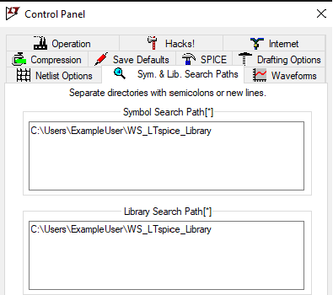
7) You may need to restart LTspice for these changes to take effect. Once completed, the symbol can be placed into any circuit by changing the drop-down arrow on the component symbol selection screen (see figure below).
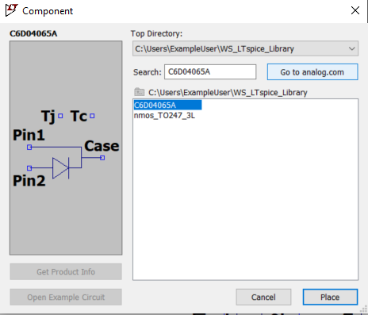
8) For MOSFETs, once the symbol is placed in the example simulation, right-click the symbol and change the Value field to your desired part number (see figure below).
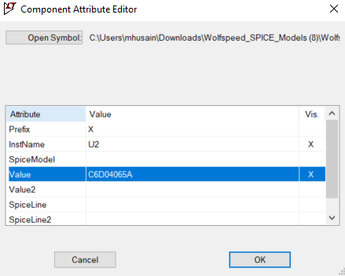
9) Once all the symbols are placed and named, use .lib command to include the subcircuit definitions of the model (see figure below).
