DC Short Circuit, DCLink Voltage Reversal, and Wolfspeed SiC MOSFET Body Diode Failure

Peter Cox-Smith.

Contents.

1 DCShort Circuit and DCLink Voltage Reversal 2

1.1 DCLink, the Capacitor, and the DC Bus 2

1.2 DCShort 2

2 SiC MOSFET Body Diode during a DCShort 3

2.1 DCShort Test Rig 3

2.2 The LCR Oscillation, DC Voltage Reversal 3

2.3 DC Voltage Reversal and the Body Diode 4

2.4 DC Link Voltage and SiC MOSFET Body Diode Failure 5

3 Protection of the Inverter 5

4 Reference 5

|  |  |  |
| --- | --- | --- |
| Issue | Date | Change |
| Rev A | 08/04/2025 | First Issue |
|  |  |  |
|  |  |  |
|  |  |  |

# DCShort Circuit and DCLink Voltage Reversal

## DCLink, the Capacitor, and the DC Bus

DCLink refers to the DC conductors that distribute DC power to system blocks such as inverters, batteries and voltage converters. The DC circuit will include a bank of capacitors that store charge and a DC bus, the conductors that distribute the current.

This is a typical Electric Vehicle set-up:

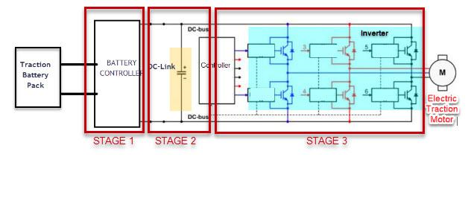

See Kemet technical resource <https://www.kemet.com/en/us/technical-resources/dc-link-design-tips.html>

The DC bus will have some inductance; although the designers will go to great lengths to minimise it, it is still present. Some typical values may be 800V operating voltage, 240uF capacitors, and an inductance of 200nH. There is some resistance in the DC Bus too including contact resistance, typically 6.5mR. These values were used in simulations and a test rig.

## DCShort

DCShort is a term used in this report to describe an event when the DC Bus experiences a short circuit. The capacitor bank will be rapidly discharged with a high peak current through the short circuit and the inductance of the bus bar itself. The DCLink circuit is a LCR loop and the voltage on the DC Bus will respond as a typical AC damped oscillation; the Inverter, Stage 3 in the diagram above, will experience voltage reversal when the diodes will conduct.

See Reference Section 4.

# SiC MOSFET Body Diode during a DCShort

System simulations have shown that the body diodes in a SiC inverter experience voltage reversal as a consequence of a DCShort event. As a follow up, SiC MOSFET parts have been tested to failure in a laboratory rig.

## DCShort Test Rig

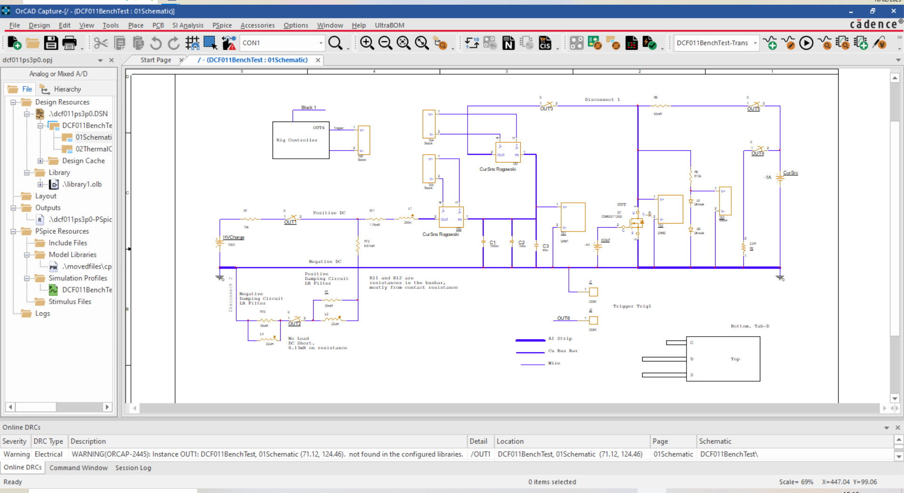

During the test sequence, the capacitors are charged, the HV source is isolated and a short circuit contactor is applied across the Positive DC and Negative DC planar copper bus bars. Rogowski coil sensors measure the current either side of the DC Link Capacitors, on one side we measure the short circuit loop and on the other side the body diode circuit loop. We also have the ability to pass 1 Amp through the body diode to assess V Forward after the DCShort event.

## The LCR Oscillation, DC Voltage Reversal

Without the MOSFET in the test circuit, the oscillation after the DCShort event was recorded at various DCLink voltages, for example:

At 194V:

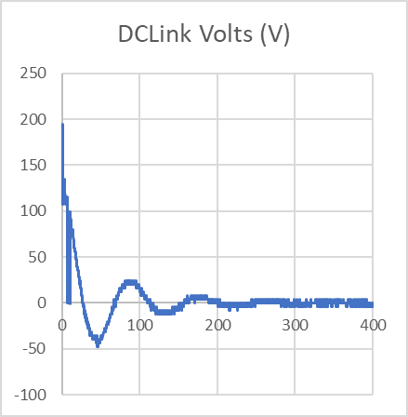

At 495V:

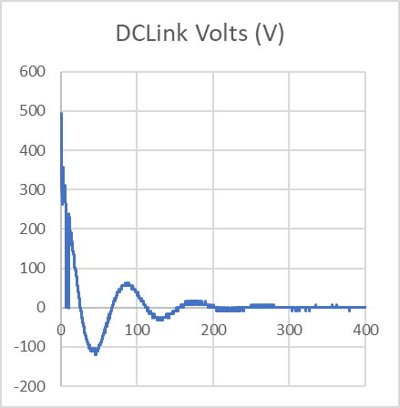 time scale in usec.

## DC Voltage Reversal and the Body Diode

The MOSFET in the test rig was a Wolfspeed CPM3 002112 0D, the oscillation after the DCShort event was recorded at various voltages, for example:

At 194V:

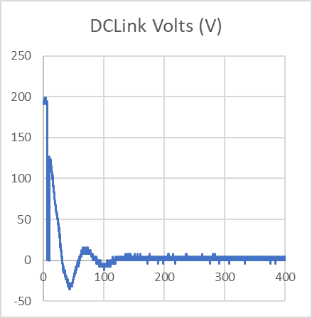 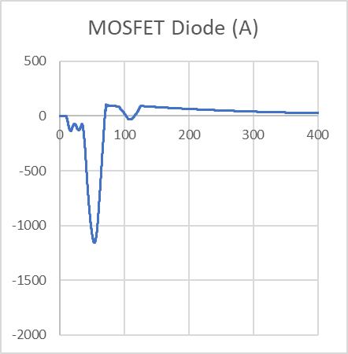 time scale in usec.

At 495V:

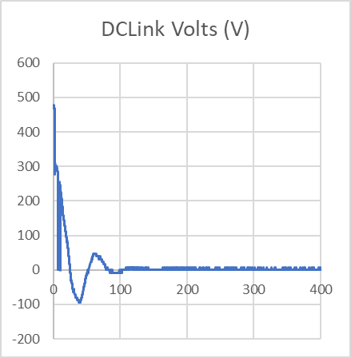 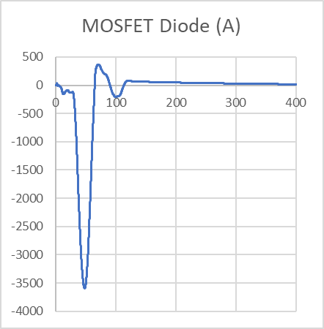 time scale in usec.

The Body Diode had failed when assessed after this test.

When an EMC filter, with leakage inductance of 13.7uH, is added to the DCLink circuit, the oscillation frequency is lower, and the body diode conduction lasts longer. At 495V:

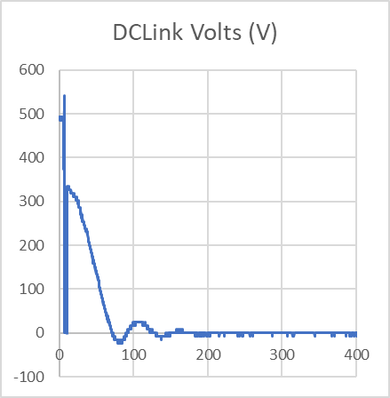 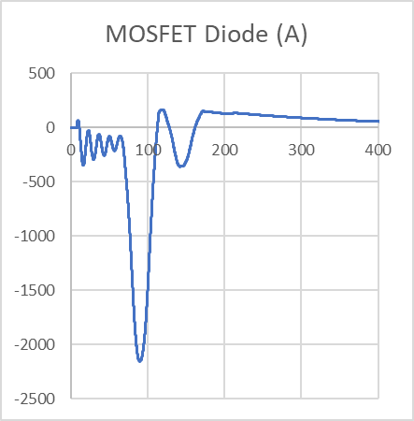

## DC Link Voltage and SiC MOSFET Body Diode Failure

6 Wolfspeed devices type CPM3 002112 0D have been tested by increasing the DCLink voltage, apply a DC short circuit across the DC bus bars, and assess the body diode. See section 2.1.

The body diodes all failed as a result of DC Link voltage reversal after a DCShort event.

The lowest DC Link voltage that caused a failure was 400V, the peak current through the diode was 1200Amps, the peak voltage reversal was -17.5V, and the pulse duration was 60usec.

The DCLink voltages at which failure occurred ranged between 400V and 750V.

# Protection of the Inverter

The question is how to protect SiC devices from voltage reversal when the DC Link experiences a short circuit?

On the basis of component tests, we should limit the DCLink voltage to 300V. No devices failed at 300V in the test rig. This is for a device rated at 1200V.

# Reference

Short-Circuit and Ground Fault Analysis and Location in VSC-Based DC Network Cables

Jin Yang, Member, IEEE, John E. Fletcher, and John O’Reilly, Senior Member, IEEE